Thank you for trusting Diamond Valley Ranch with this new and exciting addition to your family! Here is a list of possible items and some general information that may make life with puppy a bit easier for you:

CRATE- A crate sized around 24” inches is appropriate for starting out with puppy. You can also buy an adult sized crate, which is 30”, but make sure it has a divider! That way you can size the crate up as puppy grows. The reason for this is so that puppy doesn’t use one corner as a bathroom and the other to sleep in! I will give you a fleece blanket that smells like your puppy’s mom to make their crate cozy.

FOOD- Your puppy will be eating “Royal Canin Mini Puppy” Mixed with “Royal Canin Shih Tzu Puppy” (I feed the Shih Tzu variety because it is grain free and Royal Canin’s Cavalier blend does have grains, which Cavaliers tend to be very sensitive to, and can often cause skin allergies!) Both kinds of dry kibble are combined with “Canidae PURE Lamb, Turkey and Chicken” canned, Gold label, (mixed 50/50) when you bring them home. Royal Canin can only be found at specialty PET food stores, and at some (but not all) Petsmarts and Petcos, as well as online at their website (www.RoyalCanin.com), Chewy, etc. Mix 50/50, about a 1/4 cup of dry and a 1/4 can of wet, twice a day.
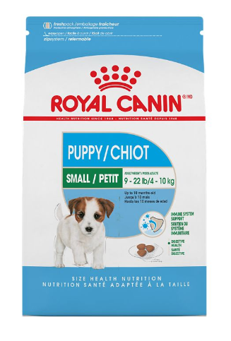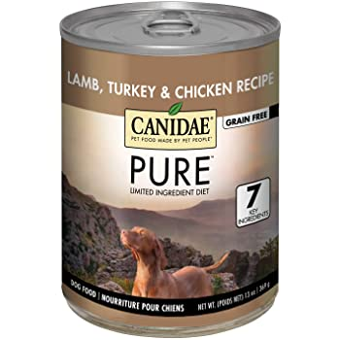

FOOD BOWLS- You will need one for water, one for food. I prefer stainless steel, ceramic can break and plastic can cause an allergic reaction and breed bacteria. I clean my dishes daily with soap and water between meals.

POTTY TRAINING- Your puppy will be 80%-90% potty trained by the time he/she is ready to come home. Do not use “pee” pads. These encourage your dog to use your home as his potty. I will provide a bag of the wood shavings that I use, that are scented with pee and poop smell. Odd, I know, but sprinkle these shavings in your yard where you would like puppy to “go”. This enables puppy to run outside, smell a familiar scent and know where to go. It makes potty training a cinch! If you are in an apartment or condo, a good trick is to buy a piece of sod (the dirt with grass on it, cut into tiny squares) and put a piece on your patio, and sprinkle the shavings on the sod.

WORMING- Your puppy has been routinely wormed with a full spectrum of the proper dewormers at the appropriate times. It is rare that worms are found in a fecal sample at your vet, but this can happen.
Please do not be alarmed. It is very unique to each individual puppy, and it is hard sometimes, due to resistance in certain individuals, to eradicate each individual parasite.

VACCINATIONS-Your puppy will come with their first two sets of vaccinations (they will need four total).
These vaccinations will be listed in your Health Record that I will give you when you pick up your puppy. Your puppy will need two additional shots, one at 12 weeks and one at 16 weeks. Your puppy has had 2 out of 4 series of age appropriate vaccinations needed (Distemper, Hepatitis, Parvo and Parainfluenza, also known as a DHPP vaccine.) I highly recommend avoiding the Lepto vaccine as it can cause neurological issues in many breeds! Discuss this with your veterinarian.

SPAY/NEUTER- Most veterinarians recommend neutering a male pup between 4 to 6 months of age, and females before their first heat (which occurs around 6 to 8 months of age.) It is imperative that you spay or neuter your pet if you did not buy on “Full” registration and do not have experience breeding animals. Once a female comes into heat it can be messy to deal with and her personality can and usually does change when in season. Males especially change in their behavior with marking/urinating/leg lifting and mounting objects! (Trust me, spay and neuter your pup for a consistent, family friendly personality and ease of dog ownership.)

FLEA TREATMENT- Your puppy will come flea free. We routinely treat for the prevention of fleas, and I do give a full bath before you receive your puppy. Some families choose to treat for fleas, and others with minimal or no pets and minimal surrounding pets do not. Please discuss these options with your veterinarian, as many medications and topical treatments are available if you so choose. I personally use and love a product called Revolution! It treats not only fleas, ticks and ear mites, but heartworms too! I advise you to steer away from Bravecto, as the product has caused some serious neurological issues, especially in small breeds.

BATHING- Your puppy only needs minimal bathing early in life. Too frequent of baths can dry out their skin. Only use mild puppy safe shampoo and avoid harsh flea treatments and other chemicals. Be very careful of getting water into their ears! This breed is susceptible to ear infections and clipping their ears up during bathing, or any other sort of lifting their ears and getting water into their ear canal can cause an infection. Keep their ears down and run water only down the top of their head, not into the ears. Ears can be cleaned out with the proper type of cleaning solution found in pet stores when needed.

COLLAR- I recommend a cat collar with a breakaway buckle for your puppy’s first collar (inside your home, not for walks)! The breakaway will release if the pup gets caught on something (a buckle closure could strangle them as they try to free themselves). A regular color with buckle closure or preferably a small harness can be used when they are older and ready to start talking walks.

